**MTech with Industry Collaboration**

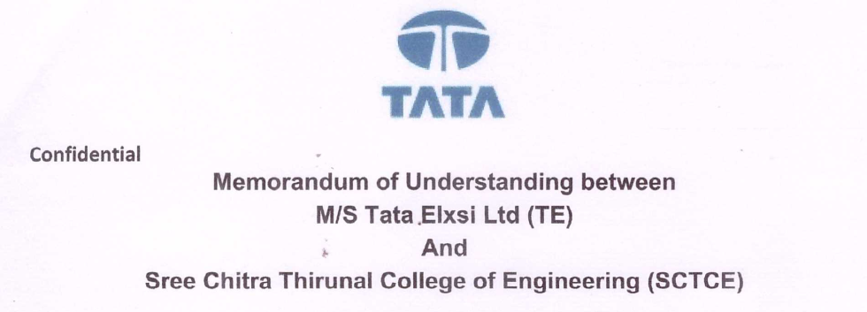

* MoU is signed with M/s Tata Elxsi for Collaboration in Academic Activities
* An M.Tech. programme on *Automotive Electronics* is offered in collaboration with Ms/ Tata Elxsi.
* After the first year of M.Tech., qualified students are offered paid internship by M/s Tata Elxsi
* On successful completion of internship, the students are offered placement.